The Harbour Bridge Outrigger Canoe Race 2021
9 October 2021

Hosted by: Waitakere Outrigger Canoe Club (Inc)

Panui

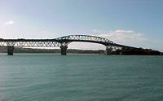

As part of its 30th birthday celebrations Waitakere Outrigger Canoe Club is hosting the classic Bridges Race in the Upper Waitemata Harbour. The Harbour Bridge race is an iron race from the Te Atatu Boating Club on the Whau River, out across the Upper Waitemata Harbour to the Auckland Harbour Bridge and return.

A Juniors/ Novices/Former members Race over 10.5km is also on the Programme.

Venue: Te Atatu Boating Club, Bridge Avenue Te Atatu

Date: Saturday 9 October 2021 – High Tide 10.18am

Entry Fee:

- $30 per Senior Paddler
- $10 per Junior Paddler
- No fee for the former Waitakere members’ teams

Entries Close on Friday 1 October 2021

Programme:

- All waka to be on-site by 8.00am

- Waka trailers to be parked behind the clubrooms (see site map)

- Seniors Race Briefing at 8.45am

- Race 1 Start (Seniors Harbour Bridges) at 9.15am

- Seniors Course: Seniors will race with staggered start for women, then mixed then men. Course is Te Atatu – around a buoy at Chelsea Sugar Works – Harbour Bridge – return same way (20km)

- Juniors, and Novices: Briefing at 11.30am

- Race 2 Start (Juniors / Novices) at 12 noon.

- Juniors / Novices Course: Course is Te Atatu - Kauri Point around the channel markers and return (see the course map).

- After racing - prizegiving over a Light Meal

Race Categories:

Juniors – boys and girls divisions - one age category (no separate J16 and J19).
Novices – one category (any combination of men and women). Apart from the steerer, must be in your 1st year of waka ama paddling.
Former Members – team can be made up of any age or gender provided paddlers are former members of the Waitakere Outrigger Canoe club – contact your old mates!!
Seniors – men’s and women’s divisions - open, masters, senior masters. Mixed (one division – no more than 3 men).

Minimum entry of three (3) crews to make a division. If there are insufficient entries the team will be placed in the next age division.

There will be one major prize of $1,000 cash to a randomly selected team. Also spot prizes.

Race Rules:

• Canoes must have 2 bailers, 6 lifejackets, tow-rope, flare/ cellphone and 2 spare paddles. All waka must have spray skirt available on the day. Race organiser’s reserve the right to make spray skirts compulsory if required.
• All waka will have to pass a safety check before racing.
- Competitors should dress appropriately for the conditions (if cool conditions polypropylenes are recommended)
• All steerers and team captains must attend the race briefing.
• Should a waka require assistance during the race, the paddler in No.3 seat must hold their paddle up vertically so that an official rescue boat or any passing waka can render assistance.
• The lead canoe will have right of way at turns.
- In the 20km race the race start line is up the Whau River. All waka need to go under the Te Atatu Bridge, out across the harbour to the Chelsea Sugar Works, around the buoy on the harbour bridge side of the sugar works, around a pylon (any one) of the Harbour Bridge, and return the same course and the finish line at the Te Atatu Boating Club. Channel markers may be ignored for this race.
- In the 10.5km race the race start line is up the Whau River. All teams must go around the green channel markers as shown on the course map and as directed at the race briefing.
• The Race Director and their officials have absolute control of the event. You must, for safety reasons, follow the instructions of any official, including those on support boats.
• Race organisers will arrange official support boats. A waiver form must be signed by all paddlers at Registration on the day.

COVID 19

All relevant COVID 19 rules and guidelines will be followed with particular advice given closer to the event as required.. See the WANZ information available at https://wakaama.co.nz/stories/read/1005341

From Out of Town and Want to Hire a Waka? Contact us and we’ll see what we can do. waitakereocc@gmail.com

Waitakere Harbour Bridge Race 9 October 2021 – Course Maps

20km Seniors Course – “Harbour Bridge”

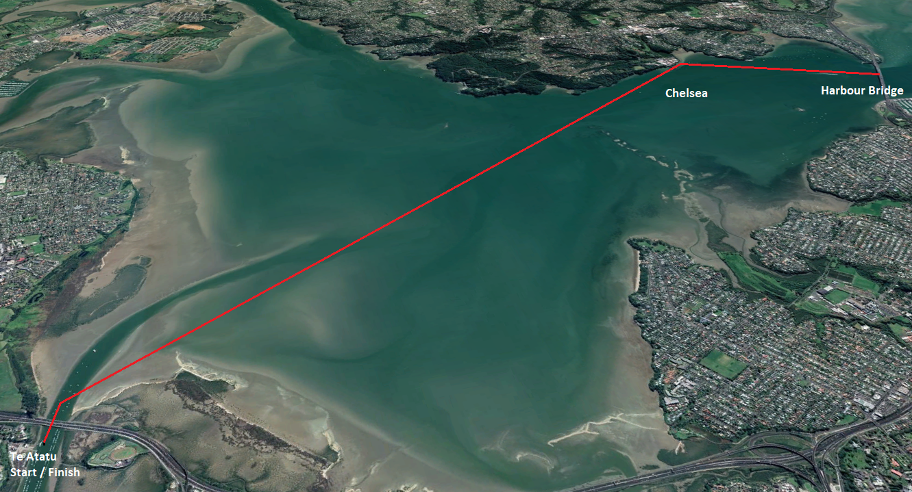

10.5km Course – “Kauri Point”
